Nepal College of Information Technology
Assessment
Fall 2012
Program : IT Time : 3 hrs
Semester : Fall (V) FM : 100
Subject : Signal System Processing PM : 50

- Candidates are requested to give their answer as far as practicable in their own words.
- The figure in the margin indicates the full marks
- Attempt ALL question

1. a) Determine the Fourier Transform of an exponentially decaying signal
x(t) = e^{-at} u(t), a>0. 7
b) Determine whether or not the given signal 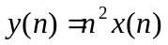is 8
i) Linear
ii) Causal
iii) Stable
iv) Shift Invariant
2. a) The following specifications are given for butterworth low pass filter
α_{p} = 0.5 dB, α_{s} = 24 dB, W_{p} = 1000 and W_{s} = 2000rad/sec
Determine
i) The filter order to meet the above specifications.
ii) The half power frequency
iii) The transfer function
iv) If the above specifications are to be met by using Chebyshev filter what is the order of the filter required? 8
b) Design an active filter to realize the bilinear transfer function with zeros at fz = 830 Hz and poles is at fp = 13 KHZ. The high frequency gain is 23 dB. Apply active realization. 7
3. a) Define z-transform. Determine the z-transform and ROC of signal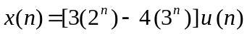. 8
b) Define circular convolution. Perform the 4-point circular convolution of sequences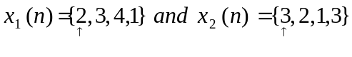 7
4. a) Find 8-point DFT of the sequence 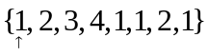using radix-2 DIT algorithm. 8
b) Obtain the direct form- I realization for the system described by the following difference equation y(n) = 0.5 y (n – 1) – 0.25 y ( n – 2) + x (n) + 0.4 x (n – 1). Also represent the same system in direct form II structure and signal flow graph. 7
5. a) Given the system y(n) = 3y(n-1) + x(n-1) 8
i) Find the system function H(z)
ii) Is this system IIR or FIR?
iii) Find the Frequency Response?
b) Convert the analog filter with system function H_{a} (s) = 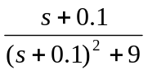into a digital filter by means of Impulse Invariance method. 7
6. a) Explain the IIR filter design by bilinear transformation method? Discuss about the advantages of this method over impulse invariance methods. 8
b) Find the Inverse Z-Transform for the given Transfer function.
H(z) = 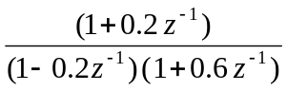 7
7) Write short notes on: ( Any two ) 5*2=10
a) Differences between Butterworth and Chebyshev filter
b) Matched Z-transform
c) Circular frequency shift property of DFT

